Guide to run automated Selenium IDE tests

# Installation

Prerequisite: Firefox browser should already be installed on your PC

## 1.1 Selenium IDE

This is an add-on which allows testers to write and playback automated Web Browser tests in Firefox. All the other add-ons add to the functionality of Selenium.

Step 1: To install the latest version on Selenium IDE visit the below mentioned website and click on the link

http://docs.seleniumhq.org/download/

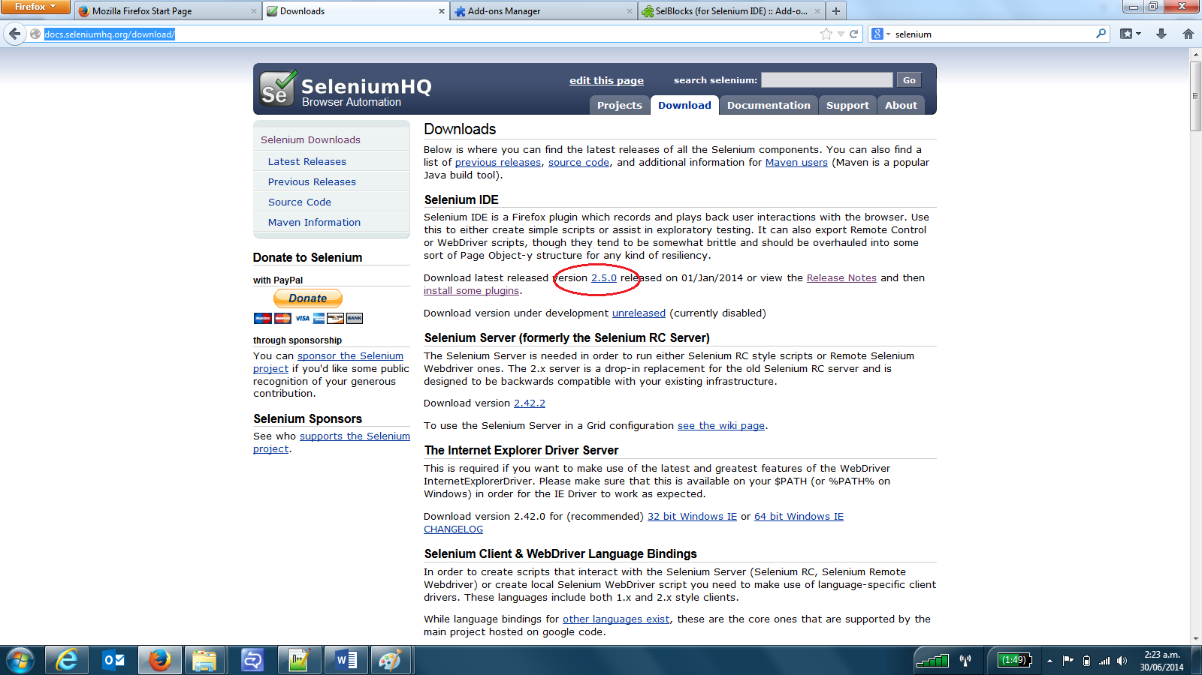

Step 2: You should see a popup for permission to install Selenium IDE. Click “Allow”

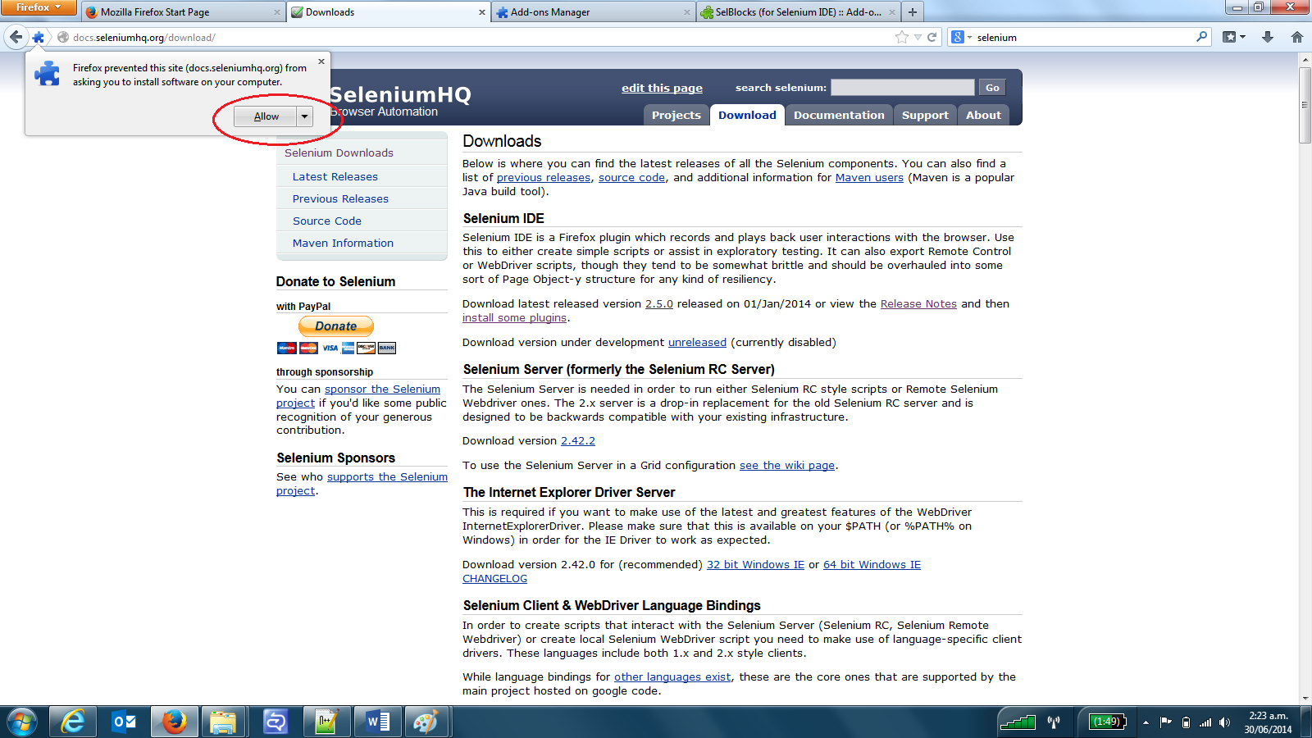

Step 3: You should see another pop-up. Click “Install Now”

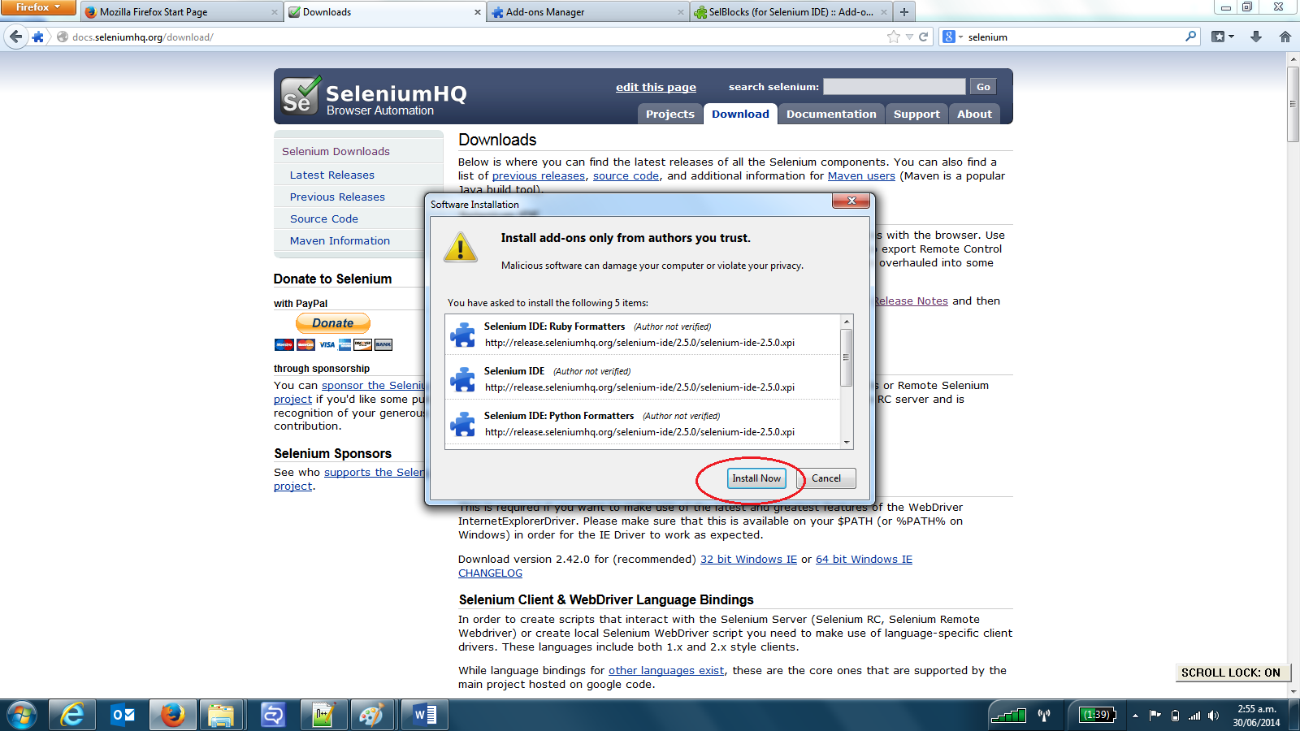

Step 4: Restart the browser. You should now see an option to launch Selenium IDE from Firefox’s menu under ‘Web Developer’ Option.

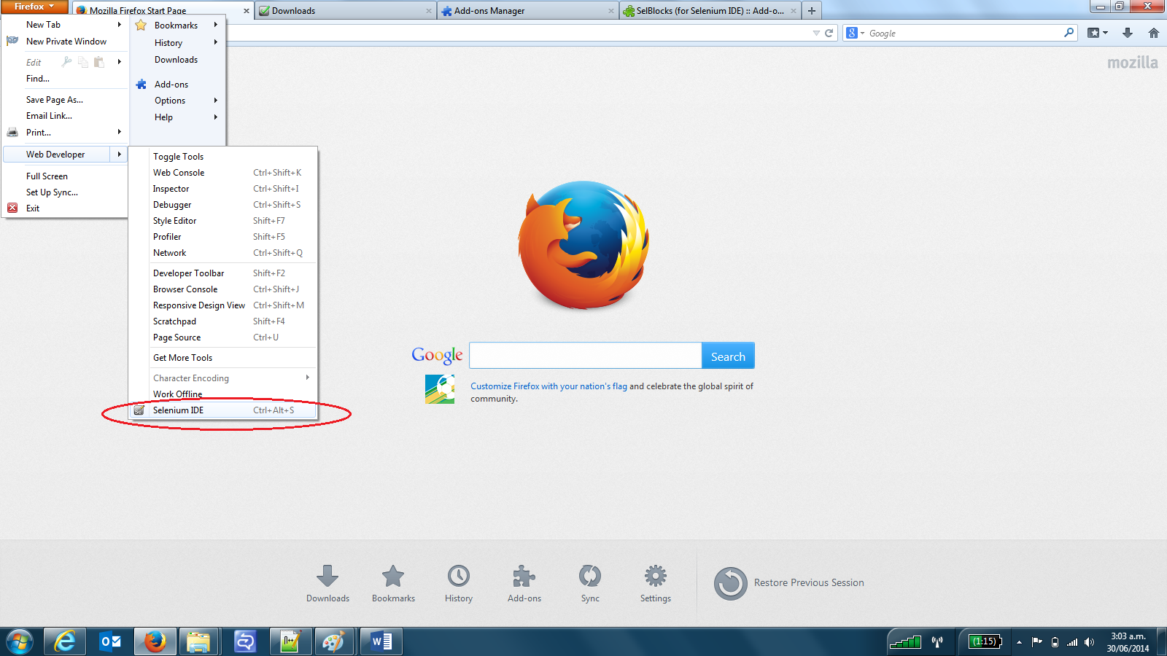

## 1.2 SelBlocks

This plugin adds Flow Control and XML based parameterization to Selenium IDE.

Step 1: Search for SelBlocks on Google or though Firefox Add-Ons marker and click “Add to Firefox”

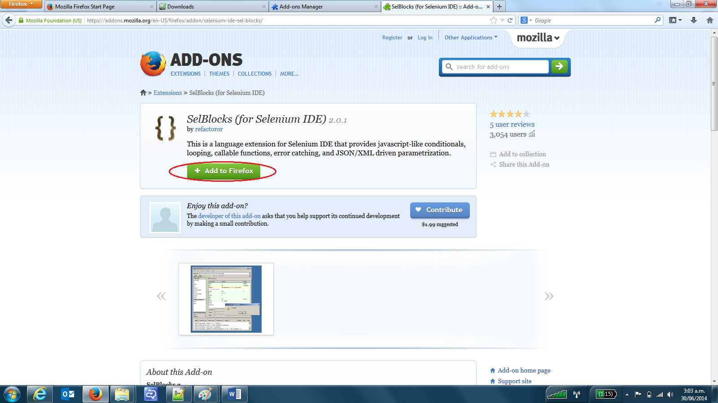

Step 2: Click “Allow” on the popup

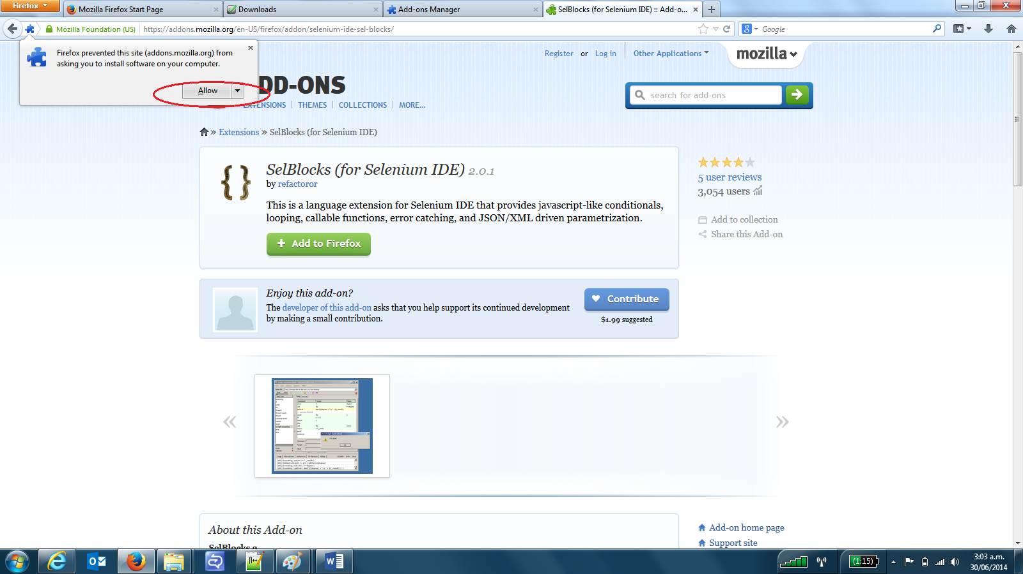

Step 3: Click “Install Now”

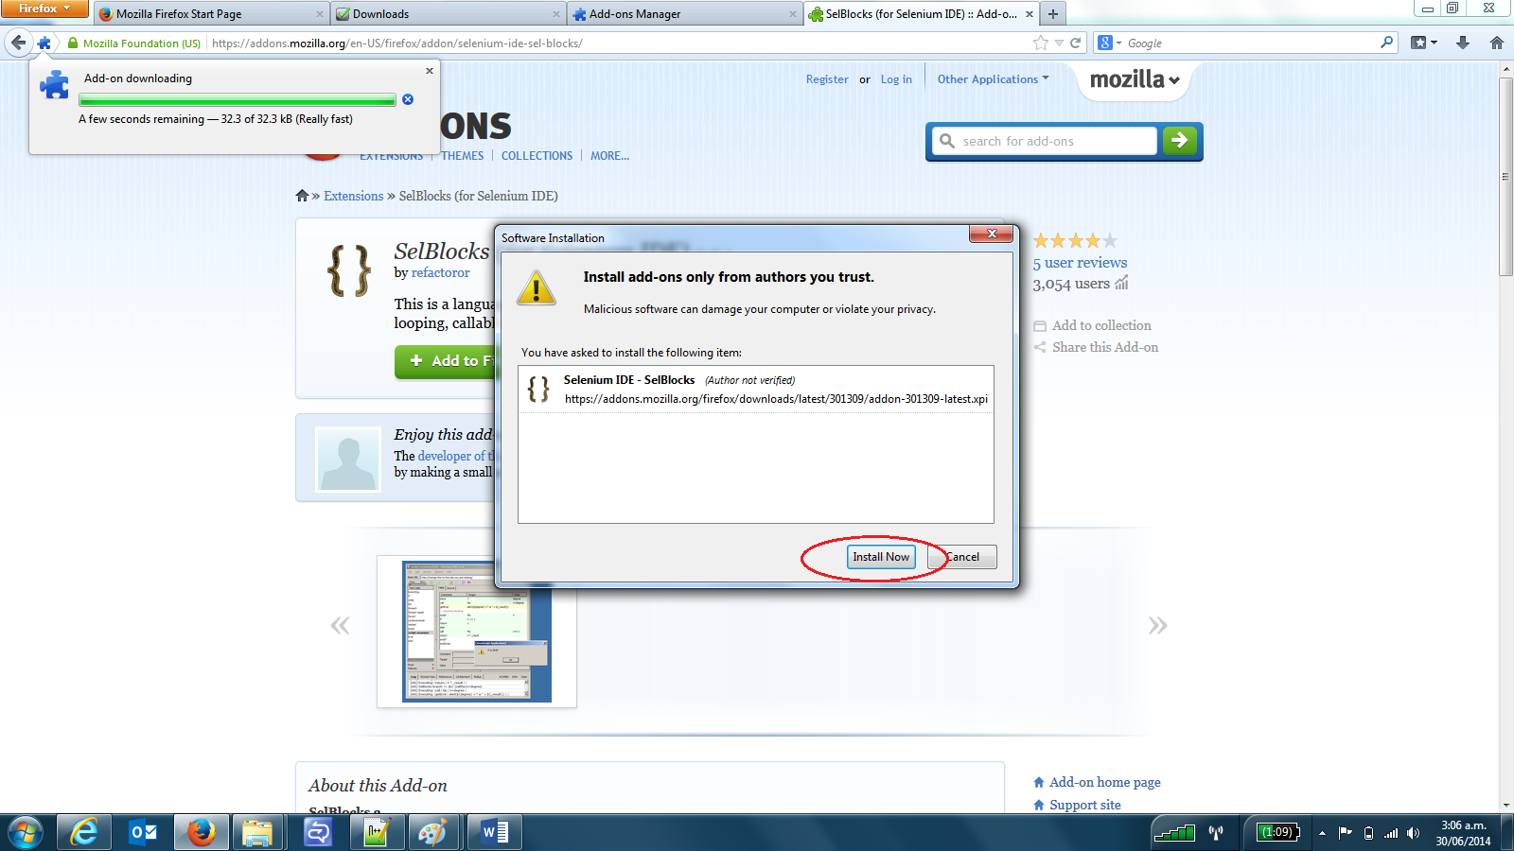

Step 4: Click “Restart” button to restart your Firefox browser.

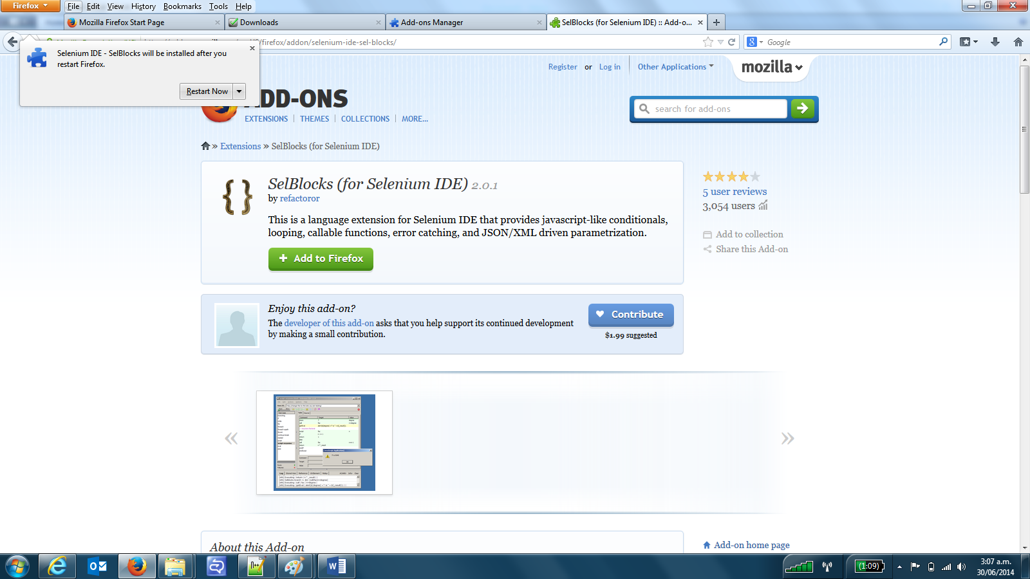

# Step-up

Step 1: Download the “Selenium Automation folder and place it in on your local drive (e.g. D: drive)

Step 2: Launch Selenium IDE from your Firefox menu’s “Web developer” option.

Step 3: From the Selenium IDE choose Option -> Option -> General to access the Selenium general setup menu.

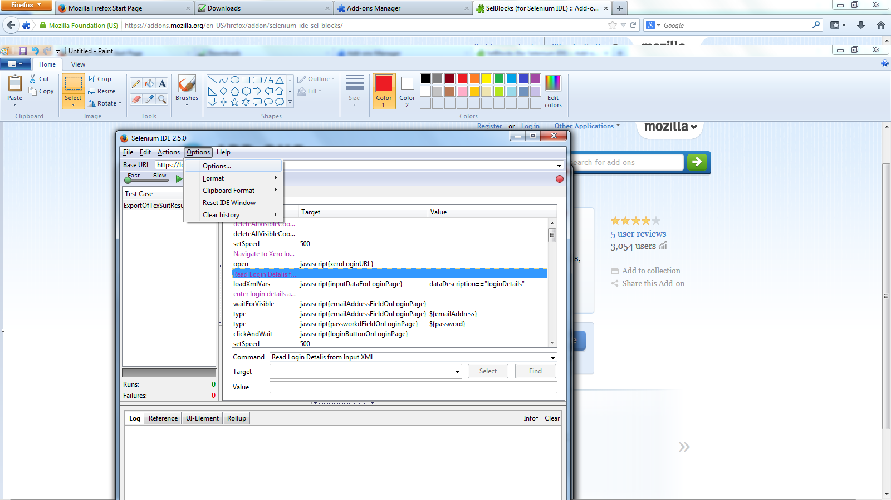

Step 4: For the “Selenium Core Extensions” field, click the “Browse” button and navigate to the “SeleniumAutomation” folder you downloaded and choose file “user-extensions.js”

Step 5: Populate the “Selenium IDE Extensions” field with the path for “testObjects.js” file, under “SeleniumAutomation” folder

Step 6: Tick the “Activate Developer tools” and “Enable Experimental features” checkboxes

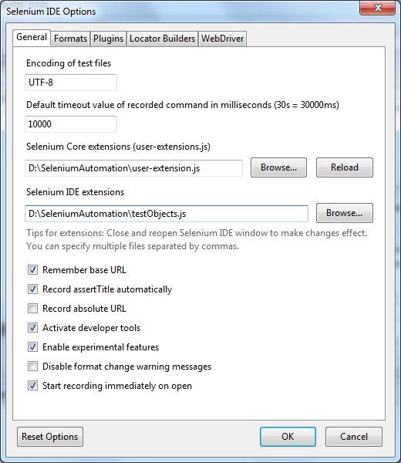

Step 7: Click “Ok”

Step 8: From the Selenium IDE menu options, choose “File” -> “Open test suite..” and navigate to “SeleniumAutomation” folder and choose file “NewRepeatingInvoiceTestSuite”

Step 9: Update line 2 and line 3 of testObjects.js (under the downloaded SeleniumAutomation folder)

**Line 2:** Provide the path for “loginDetails.xml” (also found under SeleniumAutomation folder) preceeded by “[file:///](NULL)”

E.g. if your testData.xml is present under D:\SeleniumAutomation then second line of testObjects.js should look like below

var inputDataForLoginPage= “file:///D:/SeleniumAutomation/ loginDetails.xml”

**Line 3:** Provide the path for “textData.xml” (also found under SeleniumAutomation folder) preceeded by “[file:///](NULL)”

E.g. if your testData.xml is present under D:\SeleniumAutomation then third line of testObjects.js should look like below

var inputDataForTestCases = <file:///D:/SeleniumAutomation/testData.xml>

**Please note, whenever changes are made in any file used by Selenium IDE, you need to restart the Selenium IDE for it to register the changes.**

# Running the tests

TO run the tests, click the “Play Entire test suite” button.

